Kol Simcha Torah Gazette
For Yom Kippur 5788
Vol 13 Issue 3 Tishrei 10 5788/ October 2-3, 2027
Printed L’illuy nishmas Nechama bas R’ Noach, a”h
For a free subscription, please forward your request to keren18@juno.com
Past emails can be found on the website ShabbosStories.com under Brooklyn Torah Gazette

10 Powerful Yom Kippur Practices and Their
Deeper Meaning
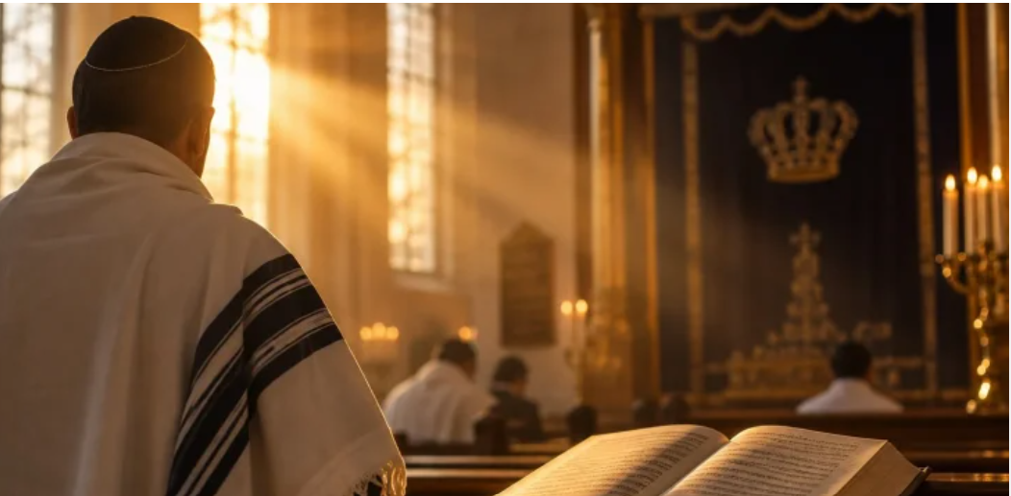

What makes Yom Kippur so spiritually powerful? Discover 10 fascinating teachings and practices connected to prayer, fasting, teshuvah, and atonement.
Yom Kippur is the holiest day of the Jewish year, a day of fasting, prayer, teshuvah, and extraordinary closeness to Hashem. Jewish sources also reveal customs and spiritual practices connected to the day, from lighting candles before the fast to the final moments of Ne’ilah. Here are 10 teachings and practices that offer a deeper look at the spiritual power of Yom Kippur.
1. Lighting Candles on the Eve of Yom Kippur Can Quiet Accusations
On the eve of Yom Kippur, candles are lit at home and in the synagogue. Lighting candles in the synagogue alludes to the heavenly illumination added to the Shechinah, which is our strength.
When lighting one’s candle, it is good to have in mind the desire to illuminate the higher worlds through an awakening from below that brings about an awakening from above.
The Zohar (Bamidbar 282) teaches that the candles of Yom Kippur correspond to the shofar of Rosh Hashanah: they quiet accusations and awaken mercy.

2. A Practice for Having Your Prayers Accepted
One practice associated with having one’s prayers accepted on Yom Kippur is to recite the following verses upon entering the synagogue:
“But as for me, through Your abundant kindness I will enter Your house; I will bow toward Your holy sanctuary in awe of You. For to You, Hashem, are my eyes; in You I take refuge. Do not expose my soul. Guard me from the trap they have set for me and from the snares of evildoers. Let the wicked fall into their own nets together, while I pass by.”
These verses are considered especially conducive to prayer, and the name expressing the holiness of the day is hinted within them.

3. A Teaching From the Holy Ari About Protecting Children
During the Torah reading on Yom Kippur, it is considered meaningful to shed tears when reading about the deaths of Aaron’s two sons and to reflect upon the grief their father experienced.
According to a teaching attributed to the holy Ari, one who sheds a tear, or at least genuinely feels sorrow over the passing of these righteous men, merits protection for their children during their lifetime.

4. A Practice From the Ben Ish Chai for Blessing and Success
The Priestly Blessing contains 15 words. It is fitting to count the words of the blessing using the joints of the hand: two on the thumb, three on each of the other fingers, with the 15th corresponding to the palm.
The Ben Ish Chai teaches the practice of counting the words in this way, with the prayer that the Creator bless all the work of our hands.

5. Kedushah During the Cantor’s Repetition Can Bring Spiritual Elevation
During Kedushah in the cantor’s repetition, we say, “Holy, holy, holy is Hashem of Hosts; the whole earth is filled with His glory,” while lifting the feet slightly with each recitation of “holy.”
According to the mystical teachings, through these words a person rises spiritually from the World of Action to the World of Formation and then to the World of Creation. In this way, the individual rises to a higher spiritual level, and the world is elevated along with them.
The holy Ari also teaches that when one recites the words, “Where is the place of His glory?” one can merit crown, wisdom, and understanding, which are alluded to within the letters of the word “where,” thereby drawing into the soul the spiritual powers associated with Yom Kippur.

6. A Spark of Teshuvah During Ne’ilah Can Bring Atonement
Rabbi Meir Simcha HaKohen of Dvinsk, author of the Meshech Chochmah, explains that at the time of Ne’ilah, the hour of sealing, Hashem in His abundant goodness responds to the tremendous outpouring of tears and regret, even in the case of the grave sin of desecrating His Name.
This is why the authors of the prayers included the words, “Why should you die, House of Israel?” (Ezekiel 33), as well as, “For I do not desire the death of the dead... return and live” (Ezekiel 18).
In other words, even if a person has not yet reached complete teshuvah as the gates are closing, there is still hope. If deep within the heart there is a genuine spark of repentance, that person can merit the atonement of Yom Kippur. Hashem sees what is in the heart, and at the time of sealing, He judges and seals a person for a good life and peace.

7. The Fast Can Atone for Days Lived Without Torah and Mitzvot
Our sages teach that a day that passes without Torah and good deeds is not truly counted among a person’s days. Fasting is described as a powerful spiritual remedy capable of reviving what is considered “dead.”
In this sense, fasting can awaken even those days that passed in spiritual darkness or were consumed by the distractions of this world. Yom Kippur encompasses all the days of the year, and the fast on this holy day can bring atonement even for those days that were spiritually wasted.

8. Yom Kippur Was Given to the World as a Day of Atonement
Sefer HaChinuch, mitzvah 185, describes the immense spiritual power embedded within Yom Kippur:
“It was among the kindnesses of Hashem to His creations that He established for them one day each year for atonement for sins, together with the repentance they would undertake. For if the sins of people accumulated year after year, their measure would be filled after two or three years, or more, and the world would be liable to destruction. Therefore, in His wisdom, Hashem saw fit, for the world’s continued existence, to establish one day each year for the atonement of sins for those who return, and from the beginning of creation He designated and sanctified it for this. And once the Creator designated it as a day of atonement, the day became holy and received from Him, may He be blessed, the power of merit, such that it assists in atonement.”
Yom Kippur itself, then, is presented as an extraordinary expression of Hashem’s kindness: a day built into creation to give people the opportunity to return, repair, and begin again.

9. Yom Kippur Is Also a Time for Joy
The gates of teshuvah remain open throughout the year. During the Ten Days of Repentance, however, repentance is described as especially accepted, as the verse says, “Seek Hashem when He may be found.”
This reaches its peak on Yom Kippur, a unique time of teshuvah for both the individual and the community and the culmination of forgiveness for the Jewish people.
Although Yom Kippur is a solemn day, there is also profound joy within it. Hashem gives us the opportunity to return to Him, and on this extraordinary day, His hand is extended to help us draw close once again.

10. A Practice for Gaining More Advocates in Your Favor
Holy books emphasize the importance of fulfilling one’s vows. They explain that when a person vows to perform a mitzvah, an angel is created, but its existence is not completed until the vow is fulfilled. Once the person carries out the commitment, that angel becomes an advocate on their behalf, reflecting the teaching that “one who performs a single mitzvah acquires one advocate.”
For this reason, some communities developed the custom of settling outstanding pledges to the synagogue before Yom Kippur. By fulfilling the commitments they had made, people entered the holiest day of the year having completed their obligations and, according to this teaching, gained favorable advocates on their behalf.
From the candles lit before the fast to the final moments of Ne’ilah, Yom Kippur offers countless opportunities to awaken mercy, deepen our prayers, and strengthen our teshuvah. These teachings remind us that the day is not only about looking back at what went wrong. It is also about recognizing the extraordinary gift of being able to return to Hashem, repair what we can, and begin again.

Reprinted from the hidabroot.com website

The Three Types of Forgiveness We're Asking
For on Yom Kippur
By Rabbi Daniel Rowe



Judaism defines three distinct levels of forgiveness, and Yom Kippur asks us to reach for all three.

Yom Kippur, the Day of Atonement, is approaching. What does atonement actually mean, and how do we get it? Is it really as simple as standing in front of God, saying "I'm sorry," and having the slate wiped clean?
Our prayers on Yom Kippur ask for three separate things and understanding the difference between them changes how we approach the whole day.
The first is selicha – forgiveness. When someone wrongs us, our first instinct is revenge. We want the person who hurt us to suffer the way we did. Asking for selicha means asking someone not to act on that instinct. We own what we did wrong, we apologize, and we ask: please don't punish me.
For small offenses, that's usually enough. But notice where the focus still sits – on us. I don't want to get punished. If we've really hurt someone, that kind of apology falls short.
What we need instead is mechila – pardon. Mechila doesn't just mean the other person won't retaliate. It means the relationship itself is restored to what it was. You can't ask for that while thinking about your own skin. You have to come to the person and say, in effect: I don't care what happens to me. What I care about is that I damaged something between us, and I want to know what it takes to heal it.
That's a fundamentally different way of showing up to another human being, or to G-d. It's not "please don't hurt me." It's "I hurt something precious and I want to repair it."
Then there's the piece unique to Yom Kippur: atonement itself. Atonement goes a layer deeper than even mechila. It's not about avoiding punishment and it's not only about the relationship. It's about the fact that the wrong exists at all, because I put it there. Jewish tradition teaches that when we do wrong, we send something harmful out into the world, and true atonement means wishing we could pull that damage back. The focus shifts entirely off ourselves: it's not "don't hurt me" and it's not even "let's fix us." It's "I can't stand that I caused you pain, because I love you that much."
What this means in practice
In the run-up to Yom Kippur, we're supposed to make a list of everyone we may have hurt over the past year. Some of them may have hurt us too – that's real, but it's beside the point right now. Except in cases where someone is still actively harming us, our job isn't to litigate what they did. Our job is to clean up our own side of the street: to name what we did, take ownership of it, and where possible, make amends.
At the same time, we're supposed to work on forgiving others, even people who never apologized. That can feel impossible. Someone hurt you five years ago and never said a word about it. How do you let that go?
One approach: remember that we're all broken people living among other broken people. If a friend snapped at you because they had a broken leg, you'd forgive them instantly. If you knew someone was struggling with mental illness, you'd extend them grace. The truth is, everyone who has ever hurt us was operating from their own damage. That doesn't excuse what they did. But it makes it possible to hold both truths at once – what they did was wrong, and they're also an unwell, struggling human being – and from that place, forgive them. (The exception, again, is anyone still actively causing us harm.

Where this leaves us with G-d
On Yom Kippur, we finally sit before G-d and admit we've fallen short of why we were put here. We're not looking for G-d to overlook that. We're saying: I care about this relationship, I care about what You want for the world, and I know I'm imperfect.
And G-d's response, in essence, is: I already knew you were imperfect. What matters is whether you're committed to doing better. As long as we take ownership and mean it, G-d wants to wipe the slate clean and start the year fresh, imperfections and all.
Perhaps the most striking part of this whole picture is that G-d's faith in us runs deeper than our faith in G-d. If we take responsibility and commit to growing, G-d is willing to forgive, forget, and reinvest in the relationship for the year ahead.

Reprinted from the aish.com website.

How to Deserve a
Positive Judgement
By Rabbi Aron Moshe Jacobson

We approach Yom Kippur with a sense of trepidation, especially once we realize that our fate as a nation and as individuals for the coming year is being sealed on this great day. With this in mind, we are forced to question ourselves, have we done our part to deserve a positive judgment? Before we can ask the question, we first have to understand what our purpose is to know if we are fulfilling it.
Rav Yaakov Galinsky, zt”l, explains that we may be able to find the answer to this question in the book of Yonah, which is read on Yom Kippur. Hashem sent Yonah to the city of Ninveh to redirect them from their ways of sinning and to help them repent.
Each one of us is Yonah, born into a world where it is incumbent on us to do the most we can to benefit and help others. Our purpose in this world is to do the most we can for others. On Yom Kippur, we read Sefer Yonah to remind us of our responsibility and to refocus ourselves on our priorities.
When we are wondering where we stand, the first question we have to answer is, “Am I doing the best and most I can to benefit and help others?”
Reprinted from the 5787 Yom Kippur email of Rabbi Yehuda Winzelberg’s Torah U’Tefilah.
Yom Kippur Thoughts

◼ SHEDDING TEARS It is commendable for a person to cry to Hashem on Yom Kippur. A king ordered a magnificent castle to be built. To discourage invaders, he fortified the castle with two defenses: an impenetrable high wall, and a deep, water-filled moat surrounding it. In times gone by, the Jewish People were protected by a mighty wall, the Beis Hamikdosh, to deter Satan and the evil inclination. Unfortunately, we have lost this stronghold. We now depend on our second line of defense, the water-filled moat of our tears, to ward off the onslaught of the yetzer hara. (Tiferes Uziel)

OPEN ARON KODESH The Aron Kodesh is left open while the Sifrei Torah are carried around the shul before Kol Nidrei to indicate that the Gates of Teshuvah are always open. (Imrei Noam)

BENDING OVER It is customary to bend forward slightly when saying the Viduy. The Shelah HaKadosh explains that this custom is based on the Gemarah which states that if one does not bow down when saying Modim in the Shemoneh Esrei, his spine will become curved like a snake. When we say Viduy, we confess our sins which originate with the Serpent – the Satan. We incline our backs like a snake, to rectify the sins that were prompted by the Serpent. (Elef Hamagein)

◼ MERIT OF NINVEH The Midrash explains why the people of Ninveh merited to be prodded to do teshuvah due to a Navi (Yonah), while no other nation – aside from Klal Yisroel – was privileged to such. For several generations after the Flood (in Noach’s time), the people still believed in Hashem and were in awe of Him. But when the wicked Nimrod came to power, he incited the people to rebel against Hashem and build the Tower of Bavel, with the intention of ascending to heaven to wage war against Hashem. The Torah then states, “From that land, Ashur went forth and built Ninveh.” (Bereishis 10:11). Noting Nimrod’s depraved ways, and fearing that his children would be swayed by him, the righteous Ashur moved away and built the city of Ninveh. Many years later, Ninveh was saved in the merit of Ashur, the single righteous man, who performed a single righteous act. Imagine how great the heavenly reward of Klal Yisroel will be for all the mitzvos and good deeds they perform! (Chizkuni al HaTorah)

Reprinted from the 5877 Yom Kippur email of The Weekly Vort.
More Painful than the Fast

Rav Mendel Kaplan, zt”l, would say, “The main thing about Yom Kippur is not to bang your chest, but to look for ways to improve yourself. Nowadays people enjoy saying a long Viduy on Yom Kippur. Rav Chaim Ozer Grodzenski, zt”l, and Rav Elchonon Wasserman, zt”l, were brothers-in-law, and one year Rav Elchonon asked Rav Chaim Ozer how his Yom Kippur fast had gone. Rav Chaim Ozer answered that the fast was bearable but confessing his Aveiros was too hard for him! That’s how the Al Cheits are supposed to be — more painful than the fast!”

The Foolish Beaver

Dayan Aryeh Leib Grossnass, zt”l, of London once spoke about the beaver. The beaver is an animal of rigorous habits. When it goes down to the river to drink water, on its return trip, it will track and follow its own footprints to get back where he came from.
Trappers know about this and they use it to their advantage. They watch for when the beaver goes down to the water, and then they place their traps on the beaver’s own tracks. Strangely enough, the animal, although it is seemingly fully aware of the trap, seems to act on ‘automatic pilot’, and never deviates from his original, set path! It prevents itself from the possibility of escaping!
Dayan Aryeh Leib concluded, “If we could question the beaver and ask him, ‘Why is it that you won’t choose another route, knowing that you are about to be trapped?’ It might answer, ‘I just can’t do that’. The beaver is trapped, as it were, by its own instincts and habits. Its own nature is its limitation, and it continues without fail to its own end.
People are similar to the beaver. On Yom Kippur we enumerate our many sins. We cry and beg for forgiveness, and we are genuine and sincere about it. However, as soon as the Yamim Nora’im have passed, what happens to us? We fall back into our ‘old tracks’ and our ‘old temptations’! And yet, just like that foolish animal, the beaver, we are fully aware that we are walking on course to our own destructions which is in our former lifestyles. Yet, we still say that we can’t break free! Let us finally break away from our bad habits and stop being like the beaver!”

Reprinted from the 5787 Yom Kippur email of Rabbi Yehuda Winzelberg’s Torah U’Tefilah
A Lost Opportunity
By Yoni Schwartz

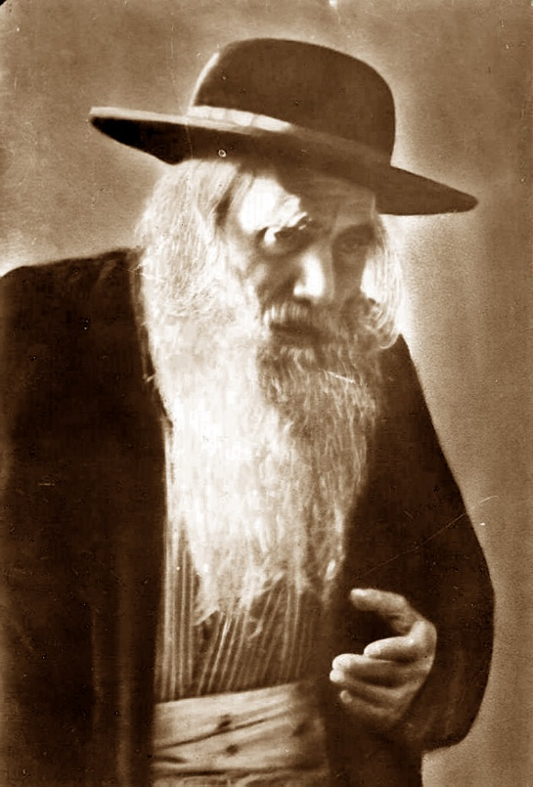
Rabbi Yosef Chaim Sonnenfeld

In Pre-State Israel, a particular Jew in Yerushalayim got sick. Rabbi Yosef Chaim Sonnenfeld, ZT”L, knew that there was a particular doctor in Vienna, where he came from, who could treat him. He raised money for this Jew to buy a boat ticket and pay for his operation. However, to his dismay, the doctor told him that the price for the operation had doubled and that he would not help him unless he had the money.
Desperate, despondent, and afraid, he felt like he had reached the end of the road. He had wasted all this time and effort only for the one person who could save his life to refuse, simply because he didn’t have enough money. He sat down on a bench in a nearby park and burst into uncontrollable tears. A well-dressed man walked up to him and asked what had happened. The Jew told him everything. The man wrote something on a piece of paper and told the Jew, “Give this to the doctor.” The Jew figured he had nothing to lose - why not give it a shot? The doctor saw the paper, operated on him, saved his life, and didn’t charge him a penny.
When he returned to Rav Sonnenfeld, he exclaimed, “Rebbi, I was saved by a miracle!” and told him the whole story. Rav Sonnenfeld asked, “Can I see the card?” He looked at it and said, “Franz Josef, the Emperor of the Austro-Hungarian Empire, wrote this card. You just happened to bump into the most powerful person in the world at just the right time! What incredible Divine Providence!”
The Jew burst out crying, “The mightiest king was standing right next to me. I could have asked for anything, and all I asked for was an operation!” Rav Yosef Chaim heard this and burst out as well: “The same is true for us during the High Holy Days. The King of all Kings is right next to us, and how many of us aren’t even aware!”

Comment: Trust in Hashem doesn’t mean being 100% certain we’ll get what we want. It’s having the courage, despite the uncertainty, to face life, putting forth our best effort, knowing that Hashem is watching over us. A new year brings new challenges, and though we may not know what the future has in store, we don’t have to face it alone. We have Hashem. Yom Kippur is the day we’re given strength to face the new year’s uncertainties with faith and courage.

Reprinted from the Yom Kippur 5787 email of Torah Sweets

